Let’s Titanic! by Gusty Chickens
P04: Makers Makin' It, Act II -- The Seequel
Devos: Emily Mai (PM), Carrie Ko, Amy Shrestha, James Lei
TARGET SHIP DATE: 2026-04-22

PROJECT DESCRIPTION: This game is a Titanic simulation game where your main goal is to save as many Titanic passengers as possible as the captain of the Titanic. The game limits your actions on the ship to 100 moves, which includes moving passengers around the ship, inspecting the passengers’ survival rates, etc. forcing you to take risky guesses and prioritize certain actions. Nothing is free (unless you get a hammer). You can load and save your progress, or play a new game as much as you want. Once you are out of moves, you will be given your survival rate and its related metrics.

PROGRAM COMPONENTS
Backend Programming
- sqlite3 & relevant data tables: data storage and retrieval
- __init__.py: Flask app used for routing / static pages
- game.py: Blueprint which handles game components
- build_db.py: Initializes the tables in the database
- db.py: Utility functions for connecting to the database
- auth.py: Blueprint which handles authentication
- populate.py: Reads from csv files and adds starting data
- constants.py: Stores various constants for the game

Pages
- startscreen.html: landing screen when you first go to the site
- register.html: registration page
- login.html: login page
- load.html: allows the user load an old save or start a new one
- lore.html: plays in a new game, introduces the player’s background
- map.html: shows different tiers & miscellaneous rooms
- room.html: shows passengers in a room and their survival rates
- result.html: result page with data visualization metrics that appears when you run out of moves; after logging out, will redirect to startscreen

SITE MAP
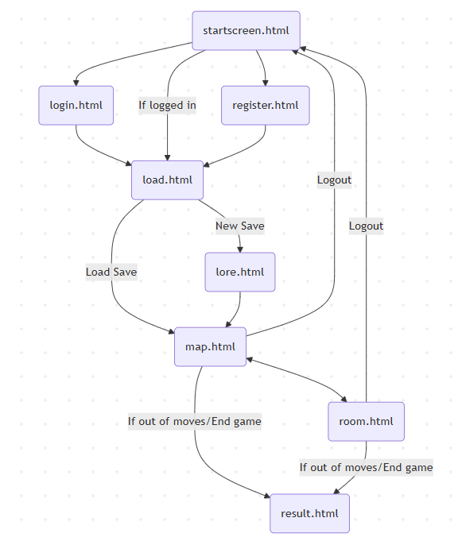

DATABASE ORGANIZATION

DefaultPassengers
INTEGER | id | PK
INTEGER | survived
INTEGER | class
TEXT | name
TEXT | sex
INTEGER | age
REAL | fare
INTEGER | isAlone
TEXT | cabin
TEXT | port

Games
TEXT | username | FK REF Users(username)
INTEGER | id | PK
TEXT | currLocation
INTEGER | charisma
INTEGER | moves
INTEGER | active

Passengers
INTEGER | game | FK REF Games(id)
INTEGER | id | FK REF DefaultPassengers(id)
INTEGER | room
INTEGER | age
INTEGER | class

Rooms
INTEGER | game | FK REF Games(id)
INTEGER | usedCapacity
TEXT | room

Users
TEXT | username | PK
TEXT | password

Items
TEXT | name
INTEGER | game | FK REF Games(id)
INTEGER | amount

COMPONENT MAP
Map: Moves NPCs and players between rooms
Authentication: Signs users in
Game: Handles actions, end game, and npc / map initialization
NPC: Provide information on NPCs
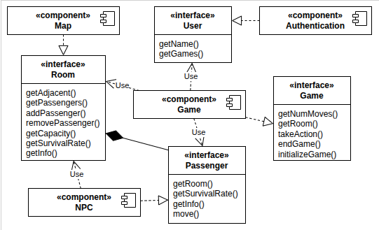

APIs
- We will not be using any APIs.

FRONT-END FRAMEWORK
- Bootstrap
  - Popovers to show capacity for each room
  - General two column layouts / headers
  - Button groups to form the map

DATA VISUALIZATION LIBRARIES
- chart.js
  - Use bar charts to show how different statistics affect their survival rate

DATASETS
- Titanic Survival Datasets: used to get Titanic NPC passengers (will utilize age, pclass, sex, passengerid, survived, isAlone, and fare columns)
  - Titanic Data 1: https://www.kaggle.com/datasets/omarmagdy711/titanic-survival-data
  - Titanic Data 2: https://www.kaggle.com/datasets/aliiihussain/titanic-survival-prediction-dataset
  - Titanic Data 3:
https://www.kaggle.com/datasets/brendan45774/test-file

TASK ASSIGNMENTS

Name | Task
Emily Mai (PM) | Data Visualization / End Game Page
Carrie Ko | CSS, Load / Home / Lore Pages
James Lei | SQLite, Datasets, Tier Pages, Items
Amy Shrestha | Map Page, Special Rooms, Items

MAP & COMPONENTS
Each action takes a move:
- Compass platform (play a gacha to drive the ship)
  - 67% chance nothing happens
  - 15% chance of losing 2 moves instead of one
  - 10% chance of getting a youth potion
  - 5% chance of getting a first class ticket
  - 2% chance of instant death
  - 1% chance of instant win!!!
- Library
  - 33% chance of $1000000 Check
  - 33% chance of $1000 Check
  - 33% chance of Debt Papers
  - 1% chance of nothing
  - Limit of 10 visits
- Gymnasium / swimming pool / squash court
  - 50% chance of getting a growth potion
  - 50% chance of getting a youth potion
  - Locked to once per room, doing this consumes an action
- Water tanks & boiler rooms
  - 30% of finding a hammer
- Crew rooms / post office
  - 70% chance of finding canned air
  - 20% chance of finding some strange souvenirs that do nothing
  - 5% chance of getting 2 youth potions
  - 5% chance of getting 1 growth potion
- Kitchen
  - Visiting restores 5 moves and you eat all the food
  - Limit of 5 visits (unless refrigerated cargo)
- Refrigerated Cargo
  - Refills uses of the kitchen (limit once per game) no matter how many uses of kitchen

ITEMS
- Hammer (permanent unless used on a passenger): when entering a miscellaneous room, the player does not lose a move
- Growth Potion (disposable): Increases someone's age by 10 years
- Youth Potion (disposable): Decreases someone’s age by 10 years
- $1000000 Check (disposable): Changes someone to 1st Class
- $1000 Check (disposable): Changes someone to 2nd Class
- Debt Papers (disposable): Changes someone to 3rd Class

